East Lancashire Road Club: Open 10 Mile Time Trial L1015
Saturday 4th May 2024: Start Sheet
Promoted on behalf of Cycling Time Trials under their Rules and Regulations
Event Secretary: Karen Bailey 07968975888 Timekeepers: Mrs Margaret Belk and Tracey Moore.
Headquarters: Sizergh, Nr Kendal, Nannypie Ln LA8 8DZ (lay-by).

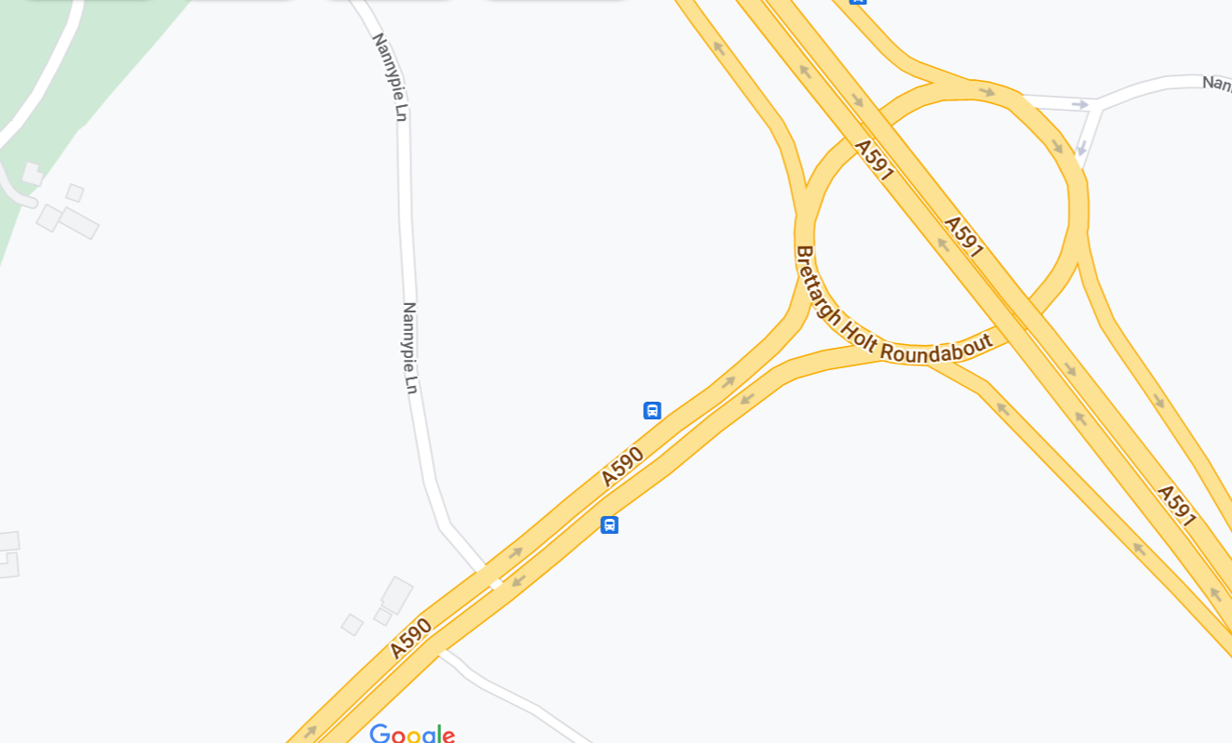
HQ

HQ opens from 17.15 First rider off 18.01
N.B. Do not park outside the Strickland Arms.
Please allow 10 minutes to ride to the start. From the HQ- follow the road back to the A590, turn left to the RAB encircle and ride back up the A590 to the Start (DO NOT PASS THE START YOU WILL BE DISQUALIFIED).
N.B. A FRONT WHITE LIGHT & REAR RED LIGHT ARE NOW REQUIRED.
NO LIGHTS = NO RIDE
Course Details
START in lay-by alongside the A590 approximately 500 yards south-west of junction with southbound A6 in line with the three white marks on kerb edge which are 20 yards west of a drainage grate which is 5 yards west of the eastern end of footpath and 25 yards east of a drainage grate almost in line with the SOS telephone point. This mark is directly in line with a wooden fence post with two angled supports in the hedge and almost in line with a ‘Please take your litter home sign’.
Proceed along the A590 in a south-westerly direction to encircle the roundabout on Lindale by-pass (5.243 miles).
Retrace along the A590 to FINISH in line with the metal cover in northern grass verge embossed ‘Charlton Iron Works Sheffield’ which is approximately 12 yards east of large road sign on slip-road to the A6 approximately 90 yards short of Levens Bridge/Levens Village road (10 MILES).

Prize List
1st 2nd 3rd 4th
Men’s Overall £40 £30 £20 £10
Men’s Veteran (40/50/60/70) £20 £10
Junior/Juvenile £40 £30 £20 £10
Women’s Overall £40 £30 £20 £10
Women’s Veteran £20
Fastest Team of 3 £10 each

One prize per rider except for the team prizes. Prizes will be sent by bank transfer
after the event unless otherwise requested. Please provide your details within one week of notification.

Number | Time | First | Second Name | Club | Gender | Age Cat
1 | 18:01:00 | Roy | Nield | East Lancashire RC | Open | Veteran
2 | 18:02:00 | Kamil | Waligora | 360cycling | Open | Senior
3 | 18:03:00 | Ste | Bolton | Giant-Kendal-Sidas.uk | Open | Senior
4 | 18:04:00 | John | Bardsley | 360cycling | Open | Espoir
5 | 18:05:00 | Basil | Monks | Edinburgh Road Club | Open | Senior
6 | 18:06:00 | Stephen | Dooley | Seamons CC | Open | Veteran
7 | 18:07:00 | Tom | Davies | Velotik Racing Team | Open | Senior
8 | 18:08:00 | Stuart | Henderson | ADDFORM Vive Le Velo | Open | Veteran
9 | 18:09:00 | Rhys | Edwards | trainSharp | Open | Junior
10 | 18:10:00 | Robin | Hennessy | Velotik Racing Team | Open | Senior
11 | 18:11:00 | Tony | Scott | GTR - Return To Life p/b Streamline | Open | Veteran
12 | 18:12:00 | David | Hilditch | Springfield Financial Racing Team | Open | Veteran
13 | 18:13:00 | Russ | Richardson | Zurbaran Racing | Open | Veteran
14 | 18:14:00 | Paul | Taylor | North Lancashire Road Club | Open | Veteran
15 | 18:15:00 | Maxwell | Hereward | 360cycling | Open | Espoir
16 | 18:16:00 | Steve | Gibson | Peak Road Club | Open | Veteran
17 | 18:17:00 | Ellis | Murray | Darlington Cycling Club | Open | Espoir
18 | 18:18:00 | Adrian | Hughes | Seamons CC | Open | Veteran
19 | 18:19:00 | Matt | Stell | Springfield Financial Racing Team | Open | Veteran
20 | 18:20:00 | Alexander | Royle | Manchester Bicycle Club | Open | Senior
21 | 18:21:00 | Andy | Horner | Springfield Financial Racing Team | Open | Veteran
22 | 18:22:00 | Ben | Huddart | Lancashire RC | Open | Senior
23 | 18:23:00 | James | Meldrum | Mersey Tri | Open | Veteran
24 | 18:24:00 | Michael | COULTER | East Lancashire RC | Open | Veteran
25 | 18:25:00 | Adam | Taylor | Wigan Whs CC | Open | Senior
26 | 18:26:00 | Simon | Horsley | Legato Racing Team (LRT) | Open | Veteran
27 | 18:27:00 | Brian | Moore | The Tricycle Association - North Western Region | Open | Veteran
28 | 18:28:00 | Liam | Hewitt | East Lancashire RC | Open | Junior
29 | 18:29:00 | Craig | Obrien | Glasgow Wheelers | Open | Veteran
30 | 18:30:00 | Matt | Hill | Zurbaran Racing | Open | Veteran
31 | 18:31:00 | Ian | Haddock | Warrington Road Club/Horton Light Engineering | Open | Veteran
32 | 18:32:00 | Ian | Sim | GTR - Return To Life p/b Streamline | Open | Veteran
33 | 18:33:00 | Nick | Hewitt | East Lancashire RC | Open | Veteran
34 | 18:34:00 | Christopher | Thomas | Blackburn & District CTC | Open | Veteran
35 | 18:35:00 | Paul | Braithwaite | Pendle Forest CC | Open | Veteran
36 | 18:36:00 | Janet | Fairclough | Liverpool Phoenix CC (Aintree) | Female | Veteran
37 | 18:37:00 | Eddie | Monteith | Warrington Road Club/Horton Light Engineering | Open | Senior
38 | 18:38:00 | Alistair | Woodman | Legato Racing Team (LRT) | Open | Veteran
39 | 18:39:00 | Robin | Gillespie | Beacon Wheelers | Open | Veteran
40 | 18:40:00 | Luca | Bednarek | Team Bottrill | Open | Junior
41 | 18:41:00 | Tony | Cullen | TricentralUk | Open | Veteran
42 | 18:42:00 | Hebe | Picking | Jadan Vive Le Velo | Female | Espoir
43 | 18:43:00 | Theresa | Taylor | Springfield Financial Racing Team | Female | Veteran
44 | 18:44:00 | Stephen | Boxall | Houghton CC | Open | Veteran
45 | 18:45:00 | Luke | Johnston | Velo Club Cumbria | Open | Senior
46 | 18:46:00 | Neil | Taylor | Wigan Whs CC | Open | Veteran
47 | 18:47:00 | Paul | Shallicker | Coveryourcar.co.uk RT - Fitted and Tailored Car Covers | Open | Veteran
48 | 18:48:00 | Steven | Hankey | Warrington Road Club/Horton Light Engineering | Open | Veteran
49 | 18:49:00 | Michael | Cox | North Lancashire Road Club | Open | Veteran
50 | 18:50:00 | Richard | Helm | Barrow Central Wheelers | Open | Veteran
51 | 18:51:00 | Ian | Cox | Fogartys Insurance Tri Team | Open | Veteran
52 | 18:52:00 | Sue | Cheetham | North Lancashire Road Club | Female | Veteran
53 | 18:53:00 | Simon | Woodliff | Ayr Burners Cycling | Open | Veteran
54 | 18:54:00 | Steve | Smales | Harrogate Nova CC | Open | Veteran
55 | 18:55:00 | Keith | Murray | Darlington Cycling Club | Open | Veteran
56 | 18:56:00 | Joanna | Cebrat | 360cycling | Female | Veteran
57 | 18:57:00 | Mark | Rowland | Selby CC | Open | Veteran
58 | 18:58:00 | Warren | Giddins | Warrington Road Club/Horton Light Engineering | Open | Veteran
59 | 18:59:00 | Louis | Thomas-Messenger | Macclesfield Wheelers | Open | Senior
60 | 19:00:00 | Chris | Booth | Giant-Kendal-Sidas.uk | Open | Senior
61 | 19:01:00 | Andrew | Smith | VC Glasgow South | Open | Veteran
62 | 19:02:00 | Andrew | Newey | Ribble Valley C&RC | Open | Senior
63 | 19:03:00 | Peter | Greenwood | Clayton Velo | Open | Veteran
64 | 19:04:00 | Mike | Westmorland | Border City Whs CC | Open | Veteran
65 | 19:05:00 | Richard | Bideau | Pendle Forest CC | Open | Veteran
66 | 19:06:00 | Peter | Grindley | Liverpool Century RC | Open | Veteran
67 | 19:07:00 | Sharon | Clifford | SheHair Racing Team | Female | Veteran
68 | 19:08:00 | Derek | Black | Wigan Whs CC | Open | Veteran
69 | 19:09:00 | Neil | Cooper | Liverpool Century RC | Open | Veteran
70 | 19:10:00 | Euan | Adam | Durham City Velo | Open | Senior
71 | 19:11:00 | Deborah | Moss | Springfield Financial Racing Team | Female | Veteran
72 | 19:12:00 | Mark | Jones | 360cycling | Open | Veteran
73 | 19:13:00 | Paul | Singleton | Kent Valley RC | Open | Veteran
74 | 19:14:00 | Beth | Macrae | Jadan Vive Le Velo | Female | Senior
75 | 19:15:00 | Rob | Graham | GTR - Return To Life p/b Streamline | Open | Senior
76 | 19:16:00 | Randle | Shenton | Border City Whs CC | Open | Veteran
77 | 19:17:00 | David | Rundall | Chorley Cycling Club | Open | Veteran
78 | 19:18:00 | Mick | Braithwaite | Springfield Financial Racing Team | Open | Veteran
79 | 19:19:00 | Neil | Swithenbank | 360cycling | Open | Veteran
80 | 19:20:00 | George | Elliott | Liverpool Century RC | Open | Senior
81 | 19:21:00 | Dougi | Hall | Border City Whs CC | Open | Veteran
82 | 19:22:00 | Christopher | Maffei | 360cycling | Open | Veteran
83 | 19:23:00 | Scott | Taylor | Springfield Financial Racing Team | Open | Veteran
84 | 19:24:00 | Tony | Johnston | Barrow Central Wheelers | Open | Veteran
85 | 19:25:00 | Mat | Ivings | Buxton CC/Sett Valley Cycles | Open | Veteran
86 | 19:26:00 | Russell | Marsden | Pendle Forest CC | Open | Veteran
87 | 19:27:00 | Lee | Spoor | Tri Preston | Open | Veteran
88 | 19:28:00 | Thomas | Percival | Velo Club Cumbria | Open | Youth
89 | 19:29:00 | Cliff | Degraff | Velo Club Cumbria | Open | Veteran
90 | 19:30:00 | Douglas | Watson | GTR - Return To Life p/b Streamline | Open | Veteran
91 | 19:31:00 | Monica | Greenwood | Macclesfield Wheelers | Female | Senior
92 | 19:32:00 | Peter | Rowe | Kent Valley RC | Open | Veteran
93 | 19:33:00 | Lucy | Mikkelsen-Barron | Derwent Valley Cycling Club | Female | Senior
94 | 19:34:00 | Simon | Myerscough | Ribble Valley C&RC | Open | Veteran
95 | 19:35:00 | Tyler | Hannay | Saint Piran | Open | Espoir
96 | 19:36:00 | William | Armstrong | Velo Club Cumbria | Open | Veteran
97 | 19:37:00 | Richard | Belk | Kent Valley RC | Open | Veteran
98 | 19:38:00 | Ben | Lovell | Kent Valley RC | Open | Veteran
99 | 19:39:00 | Tomos | Hales | Wrekinsport CC | Open | Senior
100 | 19:40:00 | Tristan | Pilling | 360cycling | Open | Senior
 | Reserve | David | Tobin | Manchester Wheelers | Open | Veteran
 | Reserve | David | Wright | Warrington Road Club/Horton Light Engineering | Open | Veteran
 | Reserve | Simon | Phillips | Stockport Tri Club | Open | Veteran
 | Reserve | Jamie | Pleavin | Liverpool Century RC | Open | Veteran
 | Reserve | Steve | Burrows | Vive Le Velo | Open | Veteran
 | Reserve | Lorenzo | Mezzullo | Manchester Bicycle Club | Open | Senior
 | Reserve | Philip | Elliott | Liverpool Century RC | Open | Veteran
 | Reserve | Hayley | Wells | Wrekinsport CC | Female | Senior
 | Reserve | Sandra | Burrows | Vive Le Velo | Female | Veteran
 | Reserve | Allan | Duncan | Fullarton Wheelers | Open | Veteran

Cycling Time Trials – North D.C. 2024 – Local Regulations L1015
The following Local Regulations have been approved by the National Committee in accordance with Regulation 38 Any breaches may lead to disciplinary action being taken.
CTT Regulation 14 Competitors Machine – FRONT WHITE LIGHT & REAR RED LIGHT.
NO COMPETITOR shall be permitted to start either a Type A or Type B event unless such competitor has affixed to the front of their machine A WORKING FRONT WHITE LIGHT, either flashing or constant, that is illuminated and in a position that is clearly visible to other road users. A WORKING REAR RED LIGHT must be affixed to the rear of the machine, that is illuminated and in a position that is clearly visible to other road users
Regulation 17: Signing-on Sheet and Signing-Out Sheet:
(a) The Competitors in all types of events must make themselves aware of any special safety instructions for the event and sign the official Signing-on Sheet when collecting their number.
(b) In Type A events a competitor must return to the events HQ either during the event or within a reasonable time after the last rider has finished the even and must (i) return their number and (ii) sign the official Signing–Out Sheet
Local Reg No 5
For the duration of the event, competitors must not ride past the timekeepers, except when competing.
Local Reg No 6
Any competitor making a ‘U’ turn in the vicinity of the start or finish will be disqualified from the event
Local Reg No 10
Course L1015, L2524 & L308 – warming up on the course is not permitted during the duration of the event.
Local Reg No 12
No parking on the car park or on the frontage of the Strickland Arms.
Local Reg No 15
Riders must keep to the left-hand side of the road except when overtaking. Failure to comply with the above may lead to disqualification.

ALL the ABOVE will be included on the START SHEET
IN ADDITION TO THE ABOVE
Riders must give their number at the finish and elsewhere on the course if requested.
Riders must NOT STAND in the road at the start or finish. (This constitutes obstruction and is a breach of Regulations).
Riders must NOT ride with their heads down.
Helmets:
All competitors MUST wear a HELMET of HARD/SOFT SHELL construction that conforms to a recognised Standard (See Regulation 15).
NOTE - ALL of the above will be included on the start sheet for the riders’ information.

